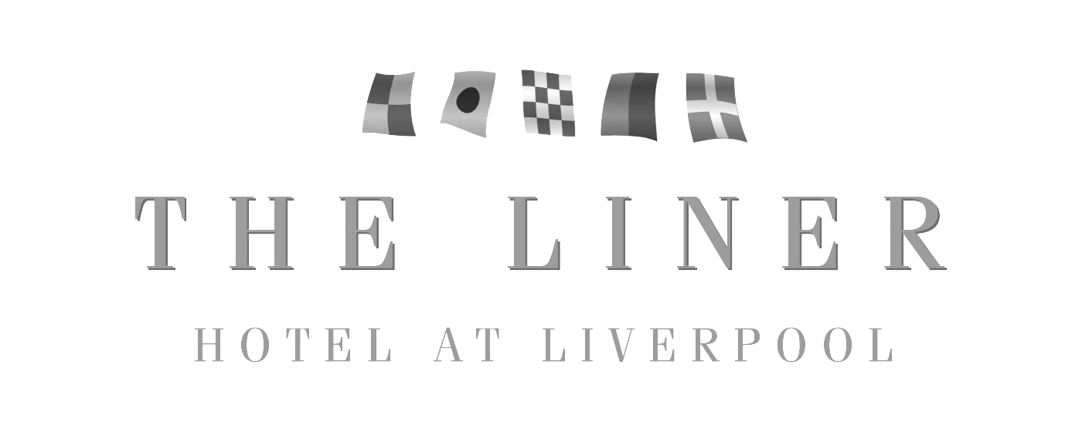

**MOTHERS DAY LUNCH MENU**

**STARTER – SERVED TO YOUR TABLE**

Leek, Potato and Cheddar Soup

With buttered croutons and chives

Chicken Liver and Chorizo Terrine

With caramelized red onion jam and oat cakes

Creamy Garlic Mushrooms

Button mushrooms cook in a creamy garlic and herb sauce finished with white wine and set on crisp ciabatta

Coconut King Prawns

Edged with a sweet chilli sauce

**FROM THE CARVERY**

Honey and Mustard Glazed Gammon

And

Rosemary and Thyme Roasted Turkey Breast

Caramelized Red Onion and Goats Cheese Tartlet (V)

*Presented with homemade sage & onion stuffing, chipolatas, Yorkshire puddings, rich roast gravy, seasonal vegetables, buttered new potatoes and herb roasted potatoes*

*Selection of house salads, bread rolls, pickles and sauces*

**DESSERT – SERVED TO YOUR TABLE**

Caramel Chocolate Fudge Cake

With fresh whipped cream

New York Vanilla Cheesecake

Set on raspberry coulis

Deep Dish Apple Pie

Topped with creamy custard

Fresh Fruit Salad

With vanilla ice cream



Deep Dish Apple Pie

Topped with creamy custard